CERAS TILES WEBSITE
Project Documentation

TITLE PAGE
Submitted By: Noor
Group Members:
- Zahra
- Fabeha
- Noor
- Kanwal
- Noreen
Supervisor: Miss maira
Batch: 2511B1
Institute: Aptech
Submission Date:30 March 2026

TABLE OF CONTENT
- Introduction
- Group Members
- Acknowledgments
- Synopsis
- Problem Definition
- Problem Statement
- Project Scope
- Functional Requirements
- Non-Functional Requirements
- Task Sheet / Project Planning
- Project Design
- System Diagrams
- Flowchart
- DFD Level 0
- DFD Level 1
- Process Diagram
- Conclusion

1. Introduction
The Ceras Tiles Website is developed to showcase different types of tiles and provide customers with an easy way to explore tile products online. The website helps users view tile designs, check product availability, and place orders easily.
The project focuses on creating a simple and user-friendly single-page website that displays tile products using image cards and provides contact information for customers.

2. Group Members
The following students worked together to complete this project:
Student Name: NOUREEN KHALID
Student ID: student1703376

Student Name: NOOR UN NISA SHAIKH
Student ID: student1703376
Student Name: FABEHA .
Student ID: student1707580
Student Name: KANWAL ASAD
Student ID: student1704116
Student Name: ZAHRA TUR RIAZ ASAD
Student ID: student1704119

3. Acknowledgments
We would like to express our sincere gratitude to our teacher and supervisor for their valuable guidance and support throughout the development of this project.
We also thank our classmates and institute for providing the resources and environment necessary to complete this project successfully.

4. Synopsis
The Ceras Tiles Website is designed to display tile products in a simple and attractive way. The website allows users to view tile images, explore product cards, and place orders through an order form.
The website also provides contact information such as location and email so customers can easily communicate with the company.

5. Problem Definition
Many tile businesses do not have an online platform to showcase their products. Customers often find it difficult to view available tile designs without visiting the store physically.
This project aims to solve this problem by creating an online tile display website where customers can easily browse tile products.

6. Problem Statement
Customers need an easy way to view tile designs and contact the company without visiting the store. A website is required to display tile products, allow customers to place orders, and provide contact information.

7. Project Scope
The scope of this project includes:
- Displaying tile products online
- Showing tile image cards
- Allowing customers to add products to cart
- Providing an Order Now form
- Showing contact information such as location and email
The project focuses on a single-page website layout for easy navigation.

8. Functional Requirements
The functional requirements describe what the system should do.
The system should:
- Display tile products
- Show tile image cards
- Allow users to click Add to Cart
- Provide Order Now form
- Show contact details
- Display sold tiles

9. Non-Functional Requirements
Non-functional requirements describe how the system should perform.
The system should:
- Have a simple and user-friendly interface
- Load pages quickly
- Work on different browsers
- Display images clearly
- Provide easy navigation

10. Task Sheet / Project Planning
The project was completed in several stages:
- Planning the website layout
- Designing the home section
- Creating tiles product cards
- Developing the order form
- Adding contact information
- Testing the website
- Preparing documentation

11. Project Design
The project design includes the layout and structure of the website. The website is designed as a single-page layout with different sections.
Main sections include:
- Home Section
- Tiles Product Section
- Sold Tiles Section
- Order Form
- Contact Section

12.System Diagrams:
Flowchart
Dfd-level0 /lebel1/etc
Process Diagrams
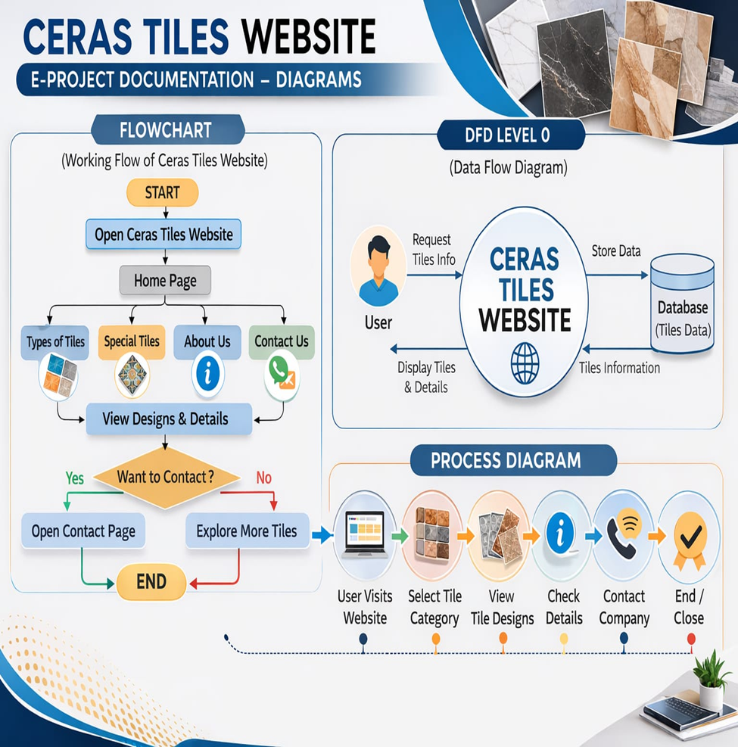

13. Process Diagram
User visits the website and explores tile products. If the user likes a tile, they can click Add to Cart or Order Now. After that, the user fills out the order form and submits the request. The website also provides contact information so the customer can communicate with the company.

14. Conclusion
The Ceras Tiles Website provides a simple platform for customers to explore tile products and place orders easily. The website design is clean, user-friendly, and easy to navigate.

Thank you for reading the documentation.
Please follow the instructions above.

